Ouseburn Farm Butterfly, dragonfly and damselfly summary report 2007.

Butterflies, dragonflies and damselflies on the Ouseburn Farm were recorded from early June to mid-September in 2007. Counts were made at approximately weekly intervals, though there is some variation to use sunny days when these insects are more active, between 11 am to 3pm.

Adult insects were counted by following the same walk through the pond meadow then around the north eastern meadow and finally around the river walk alongside the farm (see figure 1). All adults seen were counted, which risks some repeat-counts although by moving on it is unlikely that many individuals would be double counted. Note that the Small Whites, Large Whites and Green Veined Whites are under-recorded, being difficult to distinguish when flying, even at close range.

Fourteen species of butterfly were recorded, the same total number as last year. The 2007 total included one new species, the Small Tortoiseshell, a common and familiar butterfly of gardens. The lack of records in 2006 was a surprise, although a dead one was found in the pond. In 2007 no Red Admirals were found. Like the Small Tortoiseshell this is a common and widespread species and was present in surrounding parts of Newcastle so the lack of a record is probably an artefact of the survey.

Two new dragonflies were recorded. Single adults of the Southern Hawker and the Migrant Hawker were found hunting back and forth along the hedges and paths around the bridge, very typical behaviour of these species. Both are widespread species, travelling far from breeding sites, so it is likely that these were brief visitors to the Farm.

Peak numbers of the common butterflies e.g. Meadow Brown and Small Skipper were lower than in the 2006 heat-wave and anecdotal evidence suggests that many species were hit badly by the poor summer weather throughout the UK. Nonetheless the continued presence of so many species, including locally scarce butterflies such as Ringlet and Holly Blue is very encouraging.

Evidence of breeding is harder to pin down. Mating pairs of Meadow Brown and Small Skipper have been seen and a large colony of Peacock caterpillars matured on nettles in the north east meadow. The continued presence and sedentary nature of Ringlet, Large Skipper and Small Copper all suggest that they do breed in the meadows, which contain their food plants (grasses such as Cocksfoot for the Ringlet and Skipper, Common Sorrel for the Copper).

Butterflies featured in the Farm’s activities during the Ouseburn Festival, with a room full of butterfly and bug making (Figure 2). Unfortunately the poor weather over the weekend kept butterfly numbers in the meadows down but the potential for short butterfly safaris remains

Mike Jeffries,

Division of Environmental Management,
Ellison Building,
Northumbria University,
Newcastle upon Tyne,
NE1 8ST.

tel: 0191 227 3755
fax: 0191 227 4715
email: michael.jeffries@unn.ac.uk
Figure 1. Outline of butterfly recording walk.
The yellow line shows the approximate route and direction of the walk (…underneath the bridges). NB I have not walked through the horse meadow, because of the livestock. However very few butterflies have been seen flying through the field which has markedly vegetation.

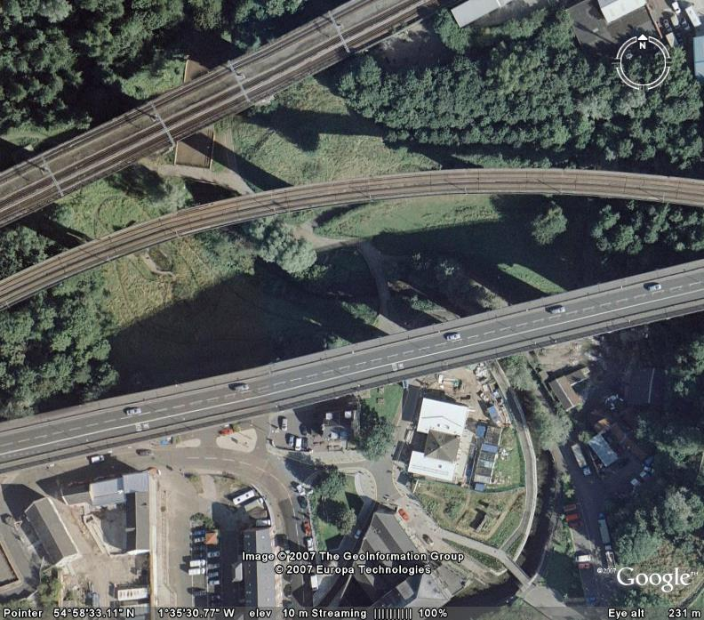

Pond meadow
Horse meadow

Figure 2. Butterfly and bug making during the Ouseburn Festival, 22nd July.

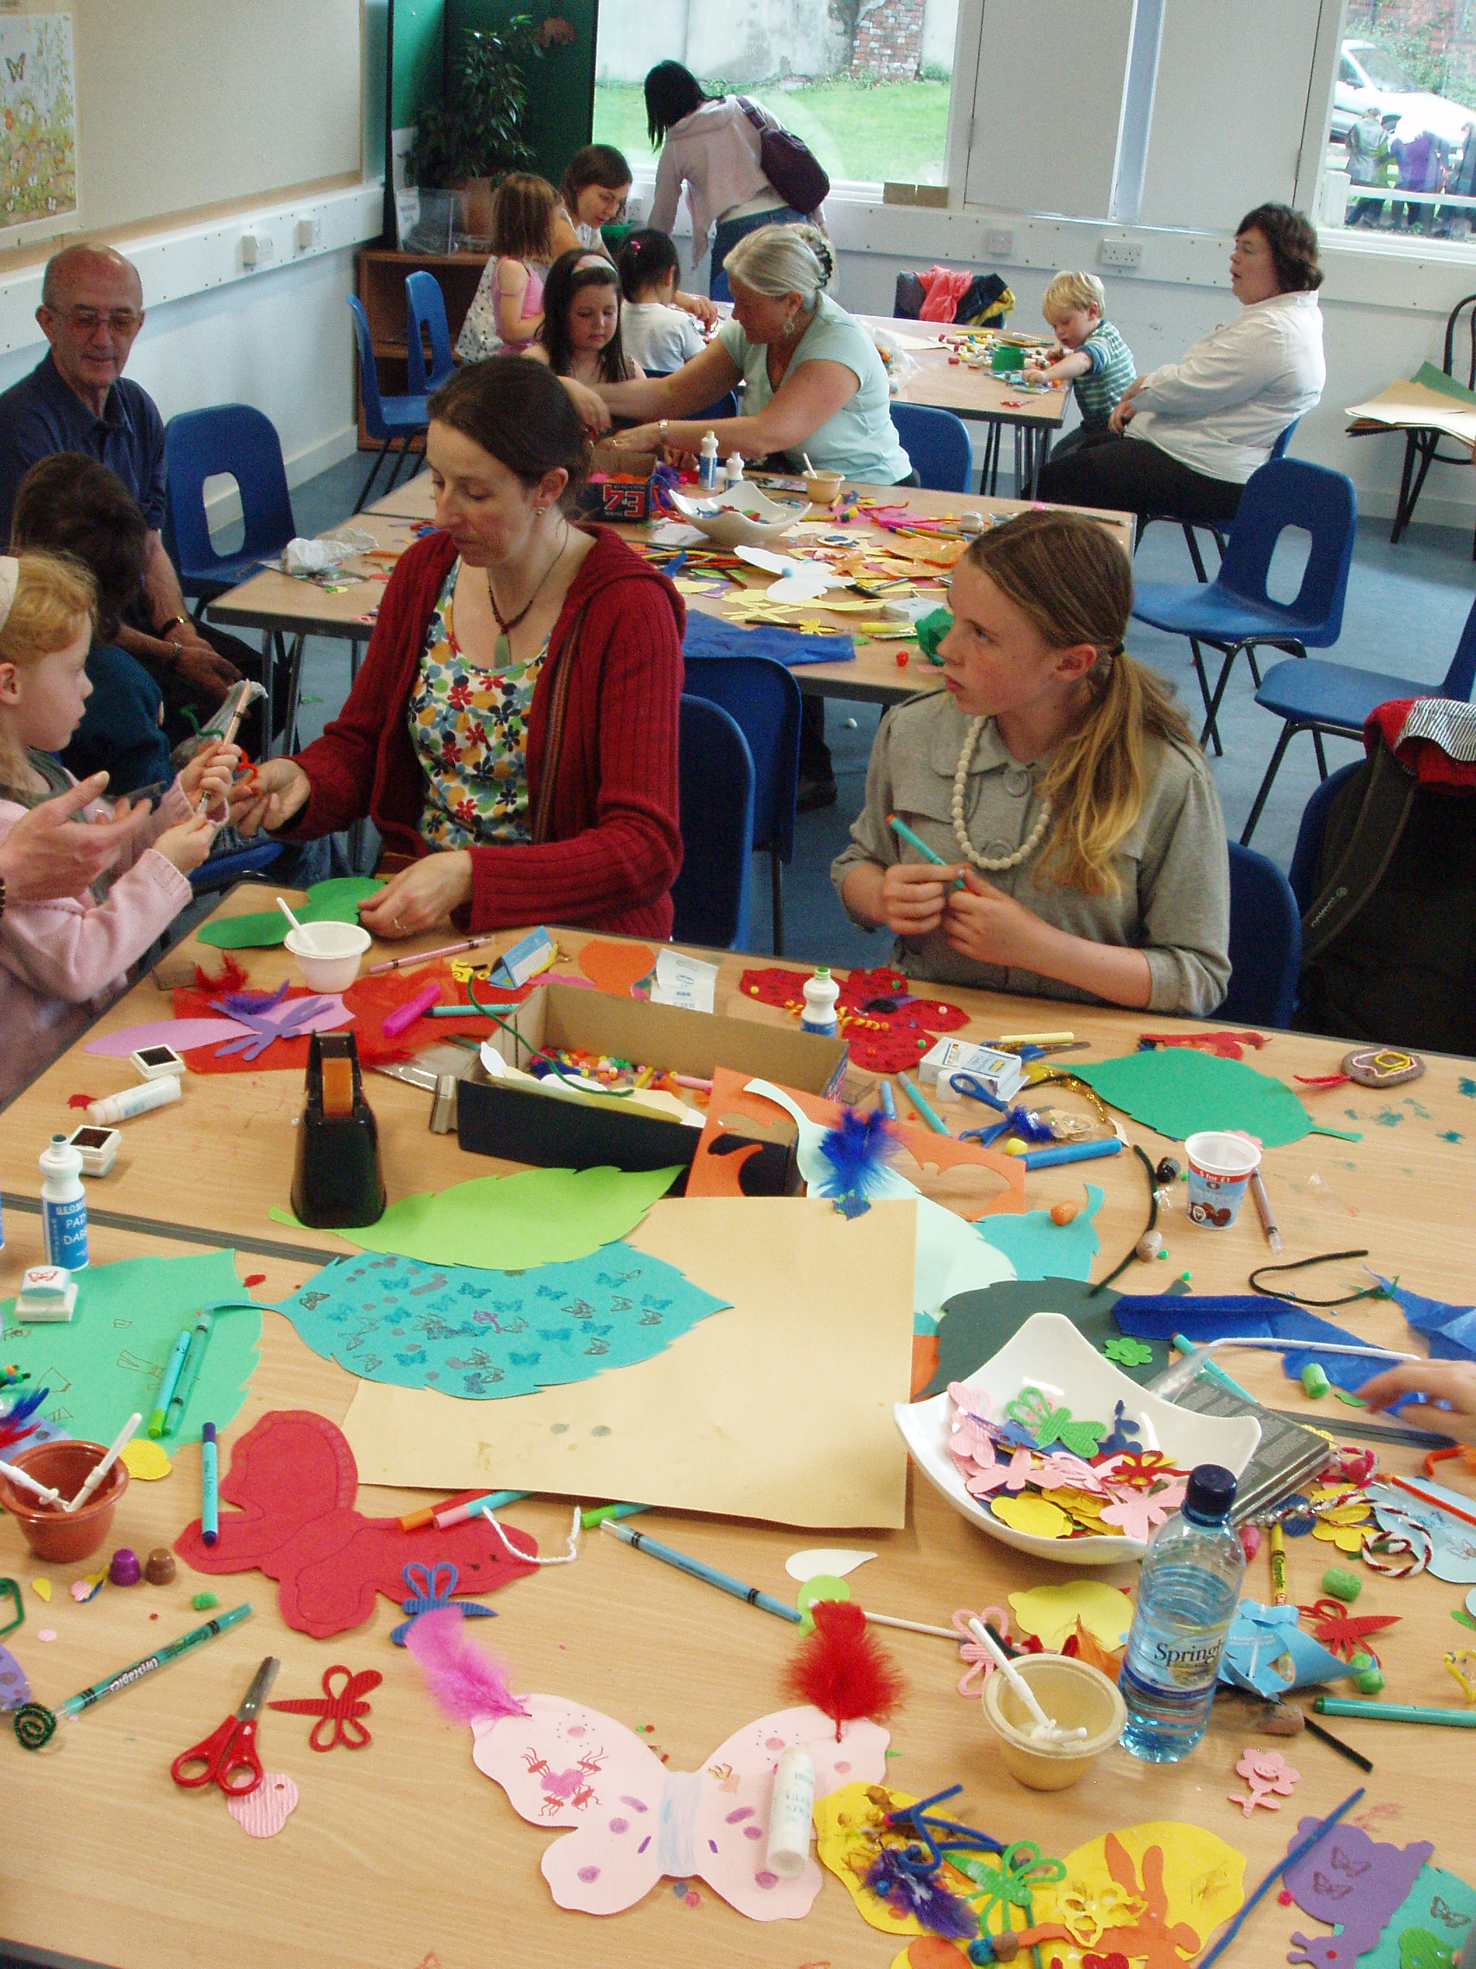

Ouseburn farm 2007 Butterflies, dragonflies and damselflies. The list includes species recorded in 2006, some of which were not recorded in 2007, e.g. the damselfly Calopetryx splendens. Species of butterflies listed in bold tend to be sedentary, living and breeding in the immediate vicinity, whilst the others tend to be highly mobile as adults
Date  Species | 9.6.07 | 17.6.07 | 26.6.07 | 1.7.07 | 8.7.07 | 15.7.07 | 22.7.07 | 24.7.07 | 28.7.07 | 5.8.07 | 10.8.07 | 26.8.07 | 1.9.07 | 6.9.07 | 15.9.07 | 19.9.07
Odonata
Calopteryx splendens
Banded demoiselle
Ischnura elegans
Blue tailed damselfly
Coenagrion puella  Azure damselfly | 2
Sympetrum striolatum  Red darter dragonfly |  |  |  |  |  |  |  |  | 1
Aeshna cyanea  Southern Hawker |  |  |  |  |  |  |  |  |  | 1
Aeshna mixta  Migrant Hawker |  |  |  |  |  |  |  |  |  |  |  |  | 1
Lepidoptera
Ochlodes venata  Large skipper |  | 2 | 1 | 1 | 1
Thymelicus sylvestris  Small skipper |  |  | 1 | 5 | 10 | 11 | 6 | 7 | 1 | 2
Lycaena phlaeas  Small copper |  |  |  |  |  |  |  |  |  | 1 | 1
Celastrina argiolus  Holly Blue |  |  |  |  |  |  |  |  |  | 1 |  | 1
Pieris napi  Green veined white |  |  |  |  |  |  |  | 1 | 1 | 1 | 7 | 2 | 3
Pieris rapae  Small white | 1 | 1 |  |  | 1 | 2 | 4 | 8 | 2 | 5 | 1 | 1
Pieris brassicae  Large white |  |  |  |  |  |  |  | 1 | 1 |  |  | 1 | 2
Inachis io  Peacock | 1 |  |  |  |  | 30+ caterpillars |  |  |  |  |  | 1 |  |  |  | 1
Polygonia c-album  Comma |  |  |  |  |  | 1 |  |  |  | 1
Aglias urticaet  Small Tortoiseshell |  |  |  |  |  | 1 |  |  |  |  | 1
Vanessa atalanta
Red Admiral
Vanessa cardui  Painted Lady | 2
Lasiommata megera  Wall Brown |  |  |  |  |  |  |  |  |  | 1 | 3
Aphantopus hyperantus  Ringlet |  |  | 1 | 2 | 1 | 1
Maniola jurtine  Meadow Brown |  |  |  | 3 | 12 | 28 | 8 | 9 | 7 | 13 | 15 | 2 | 2
Tyria jacobaeae  Cinnabar moth |  |  |  | 1 | 1 | 2

